Deaf Association of Kailali (DAOK)

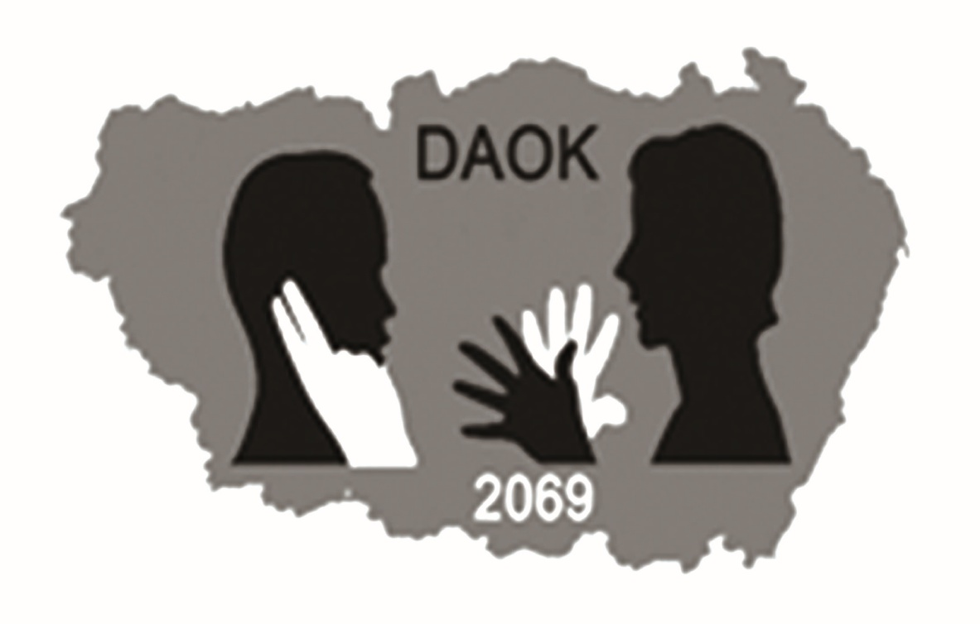
ESTD 2069

ORGANIZATIONAL PROFILE

Contact Address:
Deaf Association of Kailali (DAOK)
Shiv Shikhar margh, Dhangadhi- 5, Kailali
Phone: 977 -091-523820
Fax : 977 -091-523820
Email: kailalideaf2012@yahoo.com

Organizational Profile
1.Name of Organization: alx/f ;+3 s}nfnL
Deaf Association of Kailali (DAOK)
Main Office:
Address:Shiv Shikhar Margh, Dhangadhi – 5, Kailali
Email: kailalideaf2012@yahoo.com
Contact person for queries
1.
Name: Mr. Ramesh Bhattarai
Position: Program Manager
E-mail: bhattarairamesh@yahoo.com
Mobile: 9868585335
2.
Name: Mr. Dinesh Paneru
Position: Chairman,
E-mail: dpaneru870@gmail.com
Mobile: 9860032609 (SMS only)
2. Formal Status:
Regd. No 1736/2069-9-20 District Administration Office, Kailali./, Nepal.
Affiliation: No: 38348/070/09/03 Social Welfare Council, Kathmandu, Nepal.
District Development Committee NGO Coordination Committee, Kailali
Affiliated with National Federation of the Deaf Nepal (NDFN), 2071
Last General Assembly Date: 2072/07/22
Last Election date: 2079/06/26
Last Audit Report Date: 2080/06/12
Last Renewal Date: 2080/08/14(for one year)
Permanent Account Number: 601484366

3. Deaf Association of Kailali (DAOK)
Organizational Background
Deaf Association of Kailali (DAOK) is a non-profit Non Governmental Organization. It is registered with District Administration Office Kailali with the registration number 1736 / 069 and Social Welfare Council Kathmandu. DAOK is established in the initiation and leadership of deaf youths aiming to achieve social justice developing and strengthening deaf people to ensure deaf right and overall development of their educational, economic and social aspect. We work by right based approach in coordination, collaboration and partnership to uplift deaf people through capacity building, empowerment and advocacy.
It is dedicated to protection and promotion of Deaf people to help in every aspect. It will strive for equitable social system and equal and equitable opportunities for the betterment of the deaf. The objectives of its establishment are to endeavor hard for the attainment for quality education to the children of the rural communities of Nepal. It believes that socio-political and economic marginalization's of the communities on the basis of access to resources, opportunities and other basic facilities such as education, good environment and health are the causes for sustenance of such discriminatory system such as discrimination to deaf, traditional attitude and exploitation of minority. Hence, DAOK would work among these people to enable them to meet and made them equal as the other non deaf people who are better off in every phenomenon and walking of lives.

DAOK would work amongst the deaf people and community directly through the participation of the deprived deaf who comprising the beneficiaries at the initial and then on regional level, to work for the cause of their development and social justice. It believes that participatory democracy- a democracy where deaf peoples are full participants in all the aspects ofl development irrespective of disability, age, sex, caste, creed, religion, and ethnicity to determine their own destinies and safeguard the interest of others. It envisioned a world that is guided by principles of democracy, equality, non-discrimination, inclusion, voluntarism and prosperity of human beings all over the globe.

DAOK can play a significant part with mobilizing community at the grass roots level for the effective mechanism to overcome the present education quality and the environment of the institute, which produces youths for the future nation building. REED also gives the Nepali Sign Language (NSL) training to the Deaf and Non-deaf on the pre- education and organizes different campaigns on disability and camps for the deaf youths.

4 (A) Vision:
Our vision is deafness with dignity and equality, and a society where deaf people have equal opportunities to participate in all walks of life.
4 (B) Mission:
Our mission is to achieve equal access for deaf people in every area of their lives. We are dedicated to work for the development of the Deaf community, enhancing the quality of life, providing educational facilities, promoting social and cultural awareness while working towards independence and barrier free communication for the Deaf.
4 (C) Objectives:
The major objectives of DAOK are as follows:
- To empower the deaf by providing adult literacy in Nepali Sign Language.
- To provide job oriented vocational training for the deaf in Kailali district.
- To train potential deaf candidates as instructors for the deaf in Nepali Sign Language.
- To provide teaching classes for the purpose of training the deaf in Nepali Language.
- To provide tutorials and coaching classes to deaf students.
- To promote Sign Language orientation by conducting seminars and programs.
- To create awareness and provide educational information on Health issues among the deaf in Kailali.
- To create awareness on Deaf Culture and the identity of the Deaf Community.
- To provide the deaf with skills for their empowerment and assertion of their rights as deaf persons.
- Empowering deaf women and raising awareness on their rights, gender-related issues and the vulnerabilities of deaf women in Kailali.
- To train those with potential to be deaf leaders in the future for the betterment of the Deaf Community.
- To train potential hearing candidates as Sign Language Interpreter to support to the deaf community.
- To organize training in vocational areas, leadership and personality development for the Deaf and Hard of Hearing people in Kailali with the objective of their development and empowerment.
- To provide information, publish and print books, magazine and through websites on the Internet pertaining to deafness, the needs and problems of the deaf community.
- To coordinate with organizations to reach the above goals.
- To advocate the rights of the Deaf and the Deaf Community in every area of life.
- To conduct research on the various aspects of bilingual education for the Deaf

5. Team members:
Our team is made up of 7 Board Members and 3 full time and 1 part time professionals staff working together to provide excellent service in above mentioned thematic area of expertise along with institutional niche areas.
Pictorial form of team composition is mentioned in organization chart below:-
Organizational Chart
Executive Board

Program Manager

Account Officer
Administrative Officer
Project Coordinator

Field Worker

Executive Committee

S.N. | Full Name | Designation | Ethnicity | Elected Date
1 | Mr. Dinesh Paneru | President | Brahmin | 2079/06/28
2 | Mr. Anju Pariyar | Vice-President | Dalit | 2079/06/28
3 | Mr. Vijaya Saud | Secretary | Chettri | 2079/06/28
4 | Ms. Mina Budha | Treasurer | Janajati | 2079/06/28
5 | Mr. Pinky Bogati | Member | Chettri | 2079/06/28
6 | Ms. Suraj Khadka | Member | Chettri | 2079/06/28
7 | Ms. Jiban Chaudhary | Member | Chettri | 2079/06/28
8 | Mr. Naresh Kapdyal | Member | Chettri | 2079/06/28

6. Number of Working Staff:

S.N. | Full Name | Position | Full/Part Time
1 | Ramesh Bhattarai | Program Manager | Full Time
2 | Deepa Joshi | Interpreter | Full Time
3 | Mahesh Pandeya | Office Helper | Full Time

7. Scope/Working Area of Organization
Currently DAOK is working in Kailali district with support of programs through MyRight/SDF and support from Local Bodies focusing in various sectors of such as Sign Language Training, Campaign, Lobby, Awareness program, Delegation and so on.

8. Program carried out till date:

Program | Major focus area | Beneficiaries | Donor/Support | Period | Remarks
Enhance Educational, Economic and Communication Situation of Deaf Persons of Kailali | Kailali District | 3450 Deaf of Kailali | MyRight Nepal/SDF | 2023-2027  5 years

Logistics:

Computer Network in Office | Available
Internet Service | WiFi Zone
Number of Computers | Laptop :2 and Desktop : 2
Printer | 1
Photocopy Machine | 1
Number and specification of other equipments | Multimedia Projector-1
Inverter | 1
Steel Rack | 2
Wooden table | 3
Revolving chair | 2
Table fan | 4

